ITSP200 – Deliverable 1

Cover page

|  |  |
| --- | --- |
| Group number and name | Group number – ZACSS |
| Group member details | Student number – Chad Phillips (leader)  Student number – Itumeleng Madisha  Student number – Andrew Schwabe  Student number – Sean Thomson  Student number – Zane Smith |
| Project title | Restaurant Management System |
| Submission date | March |
| Signature of group leader |  |

**Contents**

1. Group and customer information 3

2. System Proposal 4

2.1 Overview 4

2.3 Objectives 4

2.4 User Requirements 4

2.5 Required hardware and software 5

2.6 Schedule 6

2.7 Assumptions and constraints 7

Assumptions 7

Constraints 7

2.8 Feasibility study 8

2.9 Recommendations 9

Bibliography 10

1. Group and customer information

Names and Students:

* MB2014-0719 – Chad Phillips (leader)
* MD2015-0422 – Itumeleng Madisha
* GGPQ9ZJ42 – Andrew Schwabe
* Student number – Sean Thomson
* MB2014-1043 – Zane Smith

Skills:

Chad Phillips (leader)

* Database Development
* Database Management
* Databases- MySQL and MS Access
* Coding
* Programing Languages- C#, Java, Python, PERL.
* Web Development – PHP, HTML,XML, JavaScript
* Documentation- Word

Itumeleng Madisha

* Database Development
* Database – MySQL and MS Access
* Coding
* Design
* Programing Languages- Java
* Documentation- MS Word

Andrew Schwabe

* Database Development
* Database – MySQL and MS Access
* Coding
* Design
* Programing Languages- Java, C++
* Documentation- MS Word

Sean Thomson

* Database – MySQL and MS Access
* Programing Languages- Java
* Documentation- MS Word

Zane Smith

* Database Development
* Database Management
* Databases- MySQL, MS Access, SQL, VisualBasic
* Coding
* Programing Languages- Java, PERL.
* Web Development – PHP, HTML,XML, JavaScript, JQuery, LARAVAL, Zend, $MARTIE
* Documentation- MS Word

1. System Proposal

# Overview

This system is a restaurant management system. The system will be use to implement automated stock checking, reservation bookings and an email system to suppliers.

The system implements a database using the Access database management system. The database will consist of several tables holding the data and information required by the system. A table for ingredients of the items on the menu. The database that we will use will be linked with an interface. The database will also be used to generate reports, the reports generated will also serve the purpose of constructing trends and reviewing stock levels.

Stock will also be monitored in the Database. This would keep track of the resources the restaurant uses. It will also keep track of wastage, and theft among the staff members. All foods that are used in food will be recorded by the database, and cross referenced with the recipes.

The interface will have a picture of the tables in the restaurant, which will be customizable. This would make it possible to make reservations at each table. Once the user has gotten the order, the user will then click on the table, the Table will then open up a menu. The menu will reveal all the food items that the restaurant can serve. This would result in the restaurant having the ability to change the menu and implement it without making a sample to show the user. This would give an opportunity to maximize on the report feature. The report will assist in creating future set meals based on popularity of meals.

The interface allow a user login to determine how many hours have been worked by each end user. The login will also be used to grant access to the system. And it will have a timeout system when the system is idle. The system will also allow for Admin management logins. These logins will allow for updates and delete functions. The manager logins would be able to rearrange tables, void orders, and change items on the menu and bills.

1. Aim

The aim of the project is to develop a restaurant management system for a small to medium sized restaurant, where the system will implement software for checking stock management, reservations and a billing system for tables as well as a point-of-sale.

# Objectives

* Work out all the hardware requirements for the user.
* Determine what software we will use to design our system.
* Develop a system prototype.
* To develop the actual system.
* Research other systems and take some ideas.
* To train the users on how to use the system.
* Develop a system manual.
* Choose and implement a design methodology.
* Design a development schedule.

# User Requirements

*Functional Requirements:*

* Admin should be allowed to add, update and delete from databases
* System should be able to produce daily, weekly and monthly sales reports
* Authentication of logins
* Trend tracking for popular choices
* Corrections, adjustments and cancellations to orders
* Authorization to make adjustments to Menu
* Login system and login timeouts for security

*Non-functional requirements:*

* Back-ups for the database
* security
* Database warning system of stock levels are checked every time the database is updated
* User Interface is simple and intuitive
* Data entered into the tables in the database are filtered and restricted to data types.

Technical requirements:

* The system will be client server based, linking the UI from the client to the database on the server
* The system will be developed in Java
* The system will use access for server database/MySQL
* Touch Screens for who? what use?

# Required hardware and software

Customer Hardware Requirements:

* PC/Touch screen pc
* Receipt printer
* All-in-one printer
* Keyboard
* Mouse

Customer Software Requirements:

* Java environment
* MS Access
* ODBC driver
* Java SE Runtime Environment

Development Software requirements:

* Java Development Kit
* ODBC driver
* Netbeans IDE
* MS Access
* MS Word
* GitKraken
* Github
* Slack
* Trello

Development Hardware requirements:

* Laptops/Desktops
* Printers
* Routers (for internet connection)

# Schedule

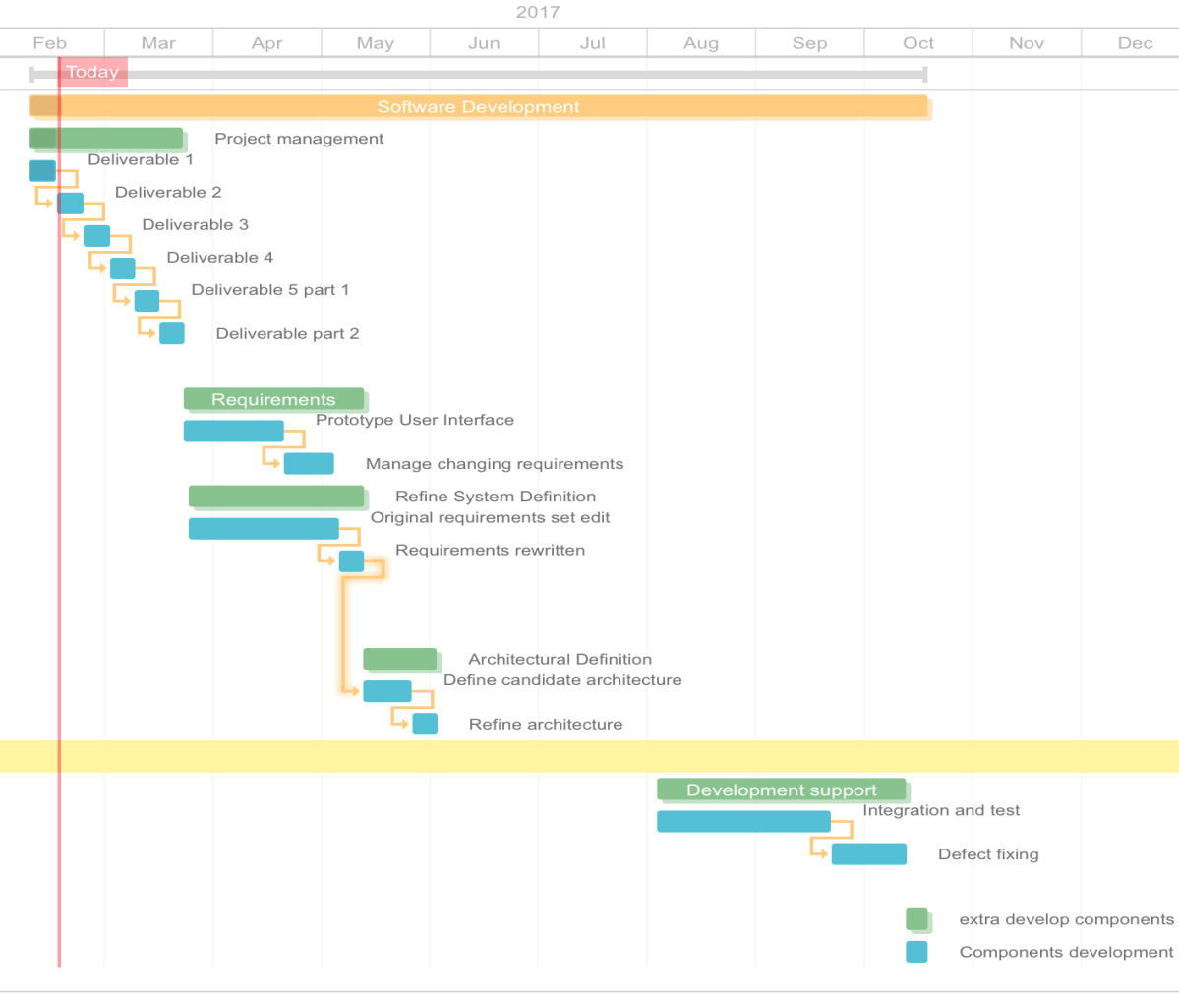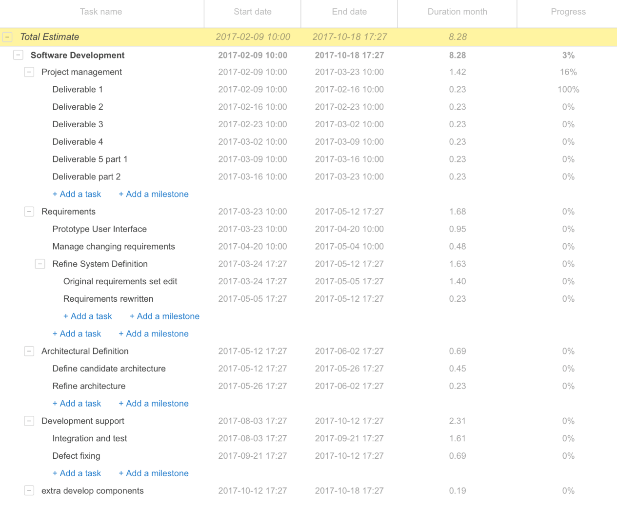

# Assumptions and constraints

# Assumptions

* Users have computer skills and understand how to use basic applications.
* How effective the result of the project is if it were to be implemented.
* The features of the project are used efficiently.
* Risks and threats are identified early, and risk analysis takes place.

# Constraints

# Feasibility study

|  |  |  |  |
| --- | --- | --- | --- |
| **Feasibility criteria** | **Weighting** | **System option 1: Develop system in-house** | **System option 2: Buy system** |
| **Operational feasibility** | 20% | **Functionality:**  The system will replace the existing system whether automated or manual, therefore it will not be new to the company thus it will not affect the day to day operations. They will however need a training period for the new system. As for new employees they would have to have a training period to learn the old system therefore it does not affect training  **Score:** 50 | **Functionality:**  Most restaurants in the industry may already have GAAP as the system (GAAP, 2017), it is a popular system amongst the industry. For those who do not this is an alternative option for them. It’s been around longer therefore has experience in the industry thus aiding the direction of them system giving adequate satisfaction.  **Score:** 20 |
| **Technical feasibility** | 20% | **Technology:**  The technology should be present for companies who already have an existing system. For those companies who don't have a system in place they would need to acquire the technology which in the case is a PC/touch PC and a printer.  **Expertise:**  For those who are already familiar with a point of sales system such as GAAP it will be fairly simple to learn. As for those without a system it would take time to train employees  **Score:** 30 | **Technology:**  Like an in-house system the technology will be similar if not the same. A PC/touch PC and a printer is necessary (GAAP, 2017).  **Expertise:**  Again this will also be similar to an in-house system. For the implementation of the system the staff will have to learn the system, though an individual in-house system has the advantage of being customized whereas GAAP is mass rolled-out.  **Score:** 45 |
| **Economic feasibility** | 40% | **Benefits:**  The benefits are that the system will help streamline the restaurants resource information by keeping track of  inventory, bookings,  waiter actions by logging activity, specials and giving recommendations on  daily operations such as deciding want item on the menus is popular and ones which are less population saving capital on buying ingredients  **Score:** 60 | **Benefits:**  The benefits are that GAAP is already developed and rolled out this means that the system will be more stable and less likely to affect the daily operations thus meaning the likelihood of continuous maintenance is less. As well as they offer free training 24/7 in a classroom environment (GAAP, 2017).  **Score:** 90 |
| **Schedule feasibility** | 20% | Maximum of 25 weeks with a optimistic 20 weeks’ timeline.  **Score:** 80 | Because the system has been developed already, the only part of the system development life cycles left is the implementation thus it will be much shorter than developing a new system. All that is required is training of the system. This training time depends on the individual but GAAP offers free training (GAAP, 2017).  **Score:** 50 |
| **Ranking** | 100% | 56 | 60 |

# Recommendations

* Restaurant owners should insure that the actual inventory of the restaurant  corresponds with that of the inventory of the system
* All wasted products should be correctly recorded in the system to keep an accurate account of ingredients
* Employees should be walked through the system thoroughly to avoid mistakes in busy times
* The customer should workout the average amount of ingredients needed for their various meals on the menu to make the system as efficient as possible
* It is recommended that the customer should contact the manufacturers of the product if any problems occur
* We recommend that the system should be the sole system of the customer to avoid clashes with the database and systems
* All updates and installations should only be done by the manufacturers of the product
* Consumers should use manufacturer recommended hardware

# Bibliography

GAAP, 2017. *GAAP.* [Online]   
Available at: https://www.gaap.co.za/downloads/GAAP_brochure.pdf  
[Accessed 23 2 2017].

GAAP, 2017. *GAAP.* [Online]   
Available at: https://www.gaap.co.za/index.html#hardware  
[Accessed 23 Februrary 2017].

GAAP, 2017. *GAAP.* [Online]   
Available at: https://www.gaap.co.za/support.html#training  
[Accessed 23 2 2017].